**CREATE AND INSERTED**

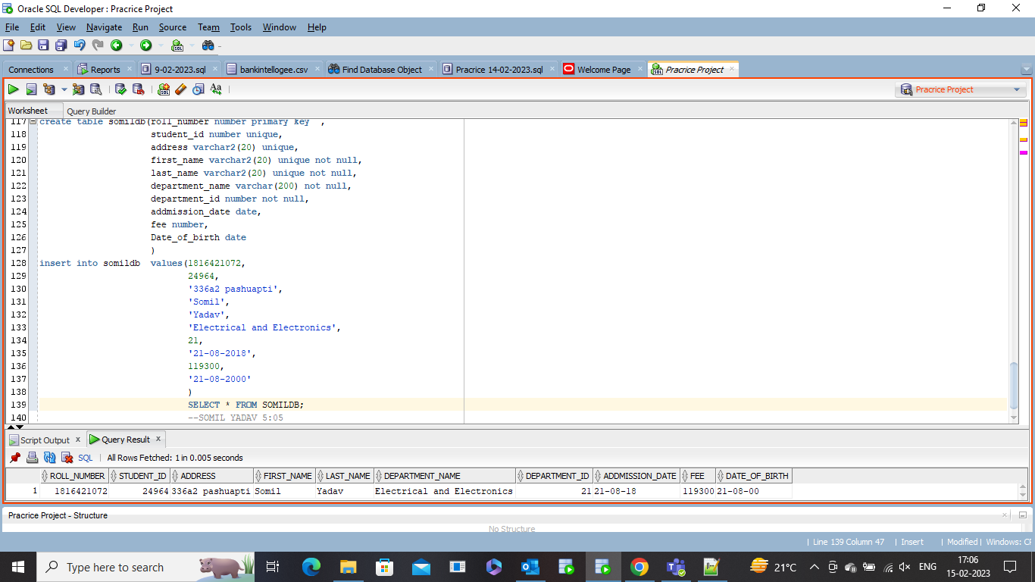

**CONSTRAINT TABLE**

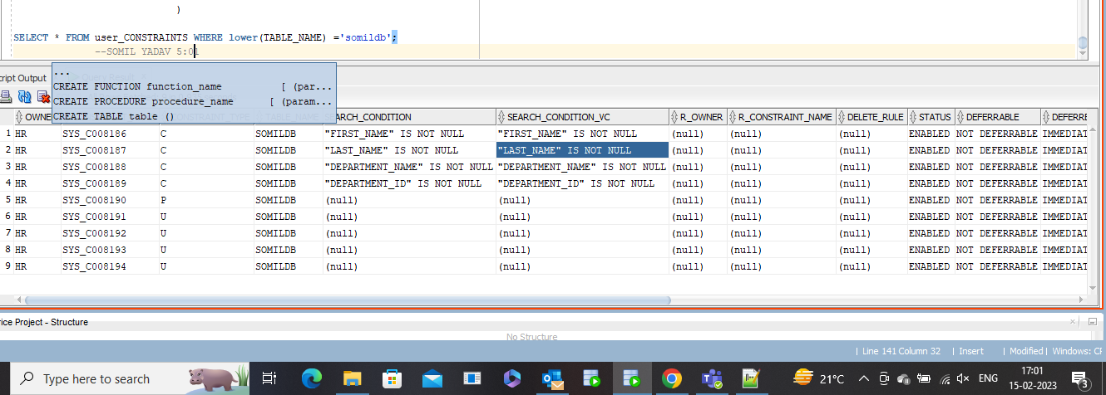

**DISABLE CONSTRAINT TABLE**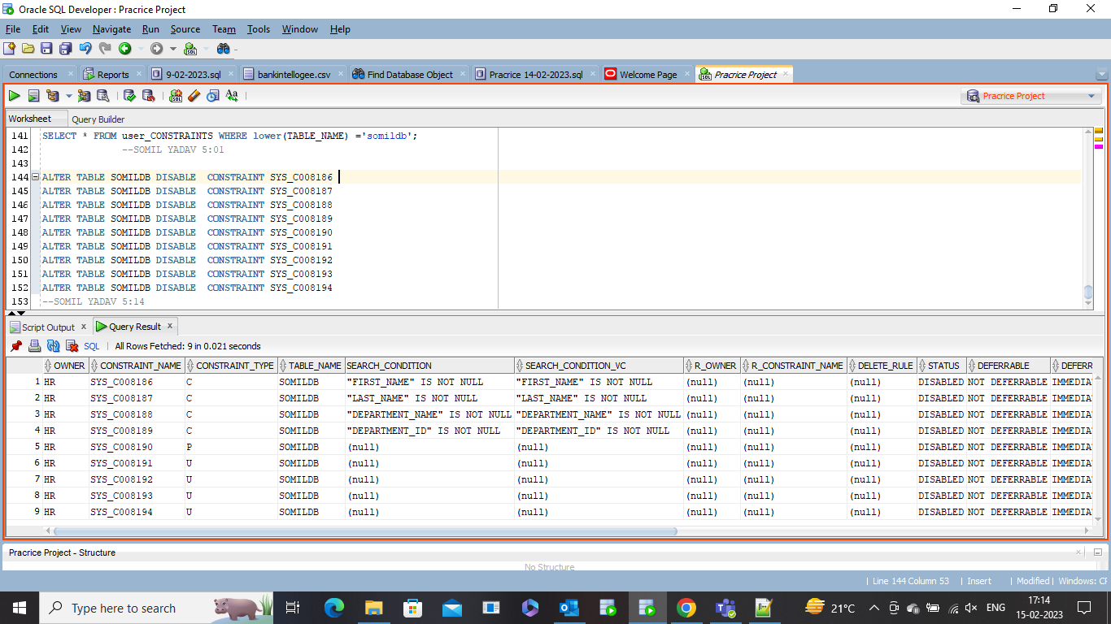

**DROP CONSTRAINT TABLE 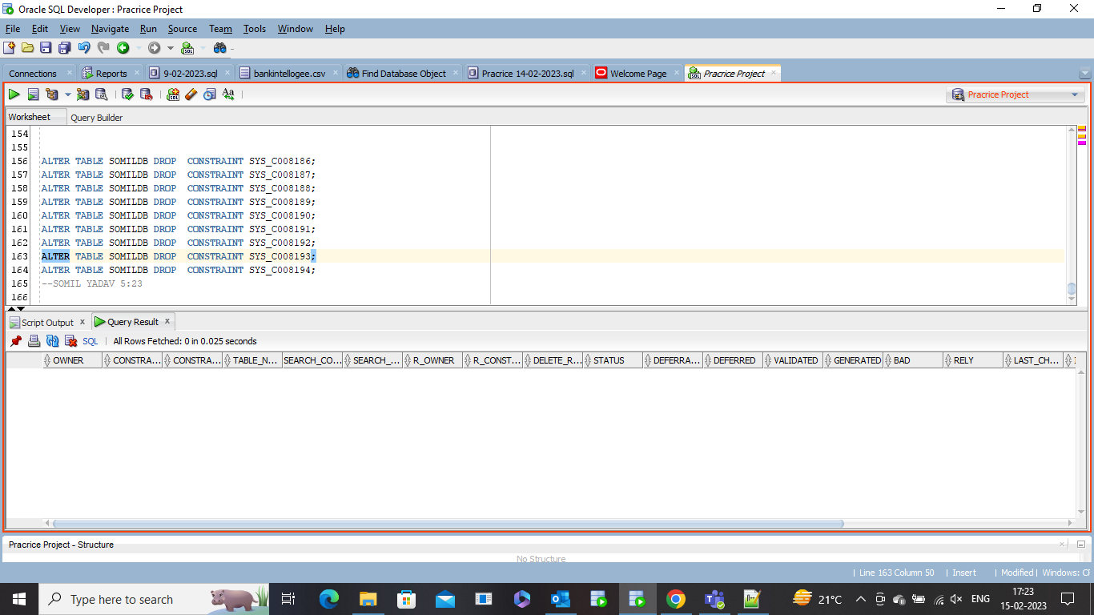 ADD CONSTRAINT TABLE** 